AICTE Complaint Monitoring Dashboard: Complete Project Guide
Oct 29, 2026 · @weeb
A single-window web dashboard that lets AICTE officials receive, route, track and close institution-related complaints across bureaus, while the complainant confirms every "solved" claim. This guide explains what we are building, how, and what we have decided.

1. Project at a glance
Item | Detail
Problem statement | SIH 2026, PS SIH26264: Integrated Dashboard for Monitoring and Tracking Institution-Related Complaint Cases Across AICTE Bureaus/Cells
Theme | Software, Smart Automation
What we build | An officials' dashboard plus a separate, read-only student dashboard
Who uses it | Bureau officers (Regulation Bureau, PGRC), Regional Offices, Senior Administration, and students (complainants)
Where complaints come from | Directly from the AICTE portal, through a REST API / webhook integration layer. Complaint filing itself is out of our scope
Core idea | Every complaint is routed to the right bureau, tracked against a government-set deadline, and closed only when the complainant confirms (or stays silent for 7 days)
Delivery | One full application, with the Llama assistant and the map view added in a second stage; a working prototype demonstrates the main flow

2. The problem and our answer
Institution-related complaints reach several AICTE bureaus and cells. Today there is no single view of them, so cases overlap between bureaus, deadlines slip, and a case can be marked solved without the complainant ever agreeing.
Our dashboard answers this in five ways:
- One institution profile per college, linked by its AICTE ID, holding all its cases and history.
- Automatic routing of each complaint to the correct bureau, so cases do not get mixed.
- Detection of the same college or issue appearing at more than one bureau, with alerts and case-linking.
- SLA timers, reminders and escalation, so no case is forgotten.
- Complainant verification before a case is closed, so officers cannot close complaints without solving them.

3. Who uses it
Role | What they see and do
Bureau Officer | Only their own bureau's cases. Marks each case Taken or Solved, uploads proof
Regional Office | All cases in their region or state, scoped automatically by login (for example Madhya Pradesh)
Senior Admin | All bureaus, escalations, officer performance and the national view with state drill-down
Complainant (student) | Only their own complaints; confirms or rejects a "solved" claim

4. All features

4.1 Features required by the problem statement
# | Feature | What it does
1 | Centralized institution profile | One profile per college linked to its AICTE ID, showing all complaints, cases and history in one place
2 | Complaint and case tracking | Unique case ID, dates, status, assigned officer, next action and disposal date for every case
3 | Cross-bureau overlap detection | Alerts when cases about the same college or issue sit with different bureaus (for example RB and PGRC); related cases can be linked
4 | Real-time analytics | Live charts for pending, processing and solved cases, with multi-filter reports (bureau, state, district, category, status, date)
5 | Workflow and audit trail | Every action recorded with who, what and when, so any step can be verified later
6 | SLA alerts and reminders | Alerts to the officer and their senior when a deadline is at risk or missed, plus reminders before it

4.2 Extra features we added
# | Feature | What it does
7 | Status views with priority list | Complaints viewed as pending, under processing or solved. A machine learning model ranks the priority list: serious complaints such as harassment rank above minor ones, and repeats within a week or a hotspot at one college raise priority further. An "Open next priority case" button jumps to the top case
8 | Auto-routing by complaint type | The category chosen on the AICTE portal (fee fraud, malpractice, hostel and so on) sends the case straight to the right bureau
9 | College list by state and district | A filterable list of every college in a state or district with its complaint counts, to spot regional patterns. The map version is planned for the full application (see section 12)
10 | Officer action: Taken / Solved | On opening a new case the officer chooses Taken (under processing) or Solved
11 | SLA timer on Taken | Choosing Taken starts the government-set time limit; missing it triggers escalation
12 | Complainant verification on Solved | The officer uploads proof when marking Solved; the complainant confirms or rejects. Confirm closes the case, reject reopens it, a second rejection escalates to a senior officer, and no reply in 7 days auto-closes it as "unverified"
13 | Reminders to bureaus | Regular reminders about pending complaints so nothing is ignored
14 | Action history | Repeated complaints per college, plus each officer's record of solved, under-processing and pending cases
15 | Feedback button | Users send feedback on the application directly
16 | Student dashboard | A read-only "My complaints" view with case ID, status, a timeline, previous complaints, and the confirm or reject step with a 7-day countdown. The student's college stays fixed
17 | Hotspot detection | If the same type of complaint (for example hostel problems) keeps arriving from different students of one college, those cases gain priority and the college is flagged

4.3 What makes our solution different
- Complainant verification on Solved with proof upload, rejection, escalation and 7-day auto-close. This is our key accountability feature.
- Repeat-complaint priority bump and hotspot flagging, so chronic problems rise, while a severity model keeps serious cases like harassment at the very top.
- Overlap detection across bureaus using multilingual text embeddings, not just exact matches.
- Per-officer and per-college action history, which tracks both officer performance and problem colleges.
- A dedicated student dashboard, so the complainant sees progress and has a say in closure.
- Explainable and auditable decisions. Routing and priority follow clear rules, every step is logged, and AI never makes a final decision.

5. Technology stack
Layer | Technology | Purpose
Frontend | React, Tailwind CSS | Officials' dashboard and student dashboard with role-based screens
 | Recharts | Interactive analytics charts (hover for exact values) and filtered reports
 | Leaflet + India GeoJSON | Map view of India or the officer's district (full application only)
Backend | Python FastAPI | REST APIs for cases, routing, verification and analytics
Integration | REST API / webhook | Receives complaints from the AICTE portal
Database | PostgreSQL | Institution profiles (AICTE ID), cases, audit trail, officer records
Background jobs | Redis + Celery | SLA timers, reminders, 7-day auto-close, escalations
Intelligence | Multilingual sentence-transformers | Duplicate and cross-bureau overlap detection, including non-English text
 | scikit-learn: Logistic Regression | Severity level of each complaint (critical, high, medium, low)
 | LightGBM (gradient boosting) | Priority score that ranks the priority list
 | SHAP | Shows why a case ranks high
 | Category-based routing rules | Uses the category chosen on the AICTE portal
 | Self-hosted Llama (Ollama or vLLM) | Full application only: complaint summaries, Hindi and Hinglish understanding, low-confidence category suggestions. Never makes final decisions
Security | JWT + role-based access control | Roles: Bureau Officer, Senior Admin, Regional Office, Complainant
 | AICTE portal SSO, OTP fallback, expiring links | Student login and verification
Notifications | Email (SMTP), SMS gateway, in-app | Alerts, reminders and verification requests
File storage | MinIO / S3 | Officer proof uploads
Deployment | Docker, NGINX | Containerized, self-hosted, reverse proxy
Why this stack:
- Fully open source, so no licensing cost.
- Data and models are self-hosted, so complaint data stays private.
- Routing and priority are explainable and auditable.
- Complaints are mostly in English, and the embeddings model keeps the system ready for other languages if AICTE approves them.

6. System architecture
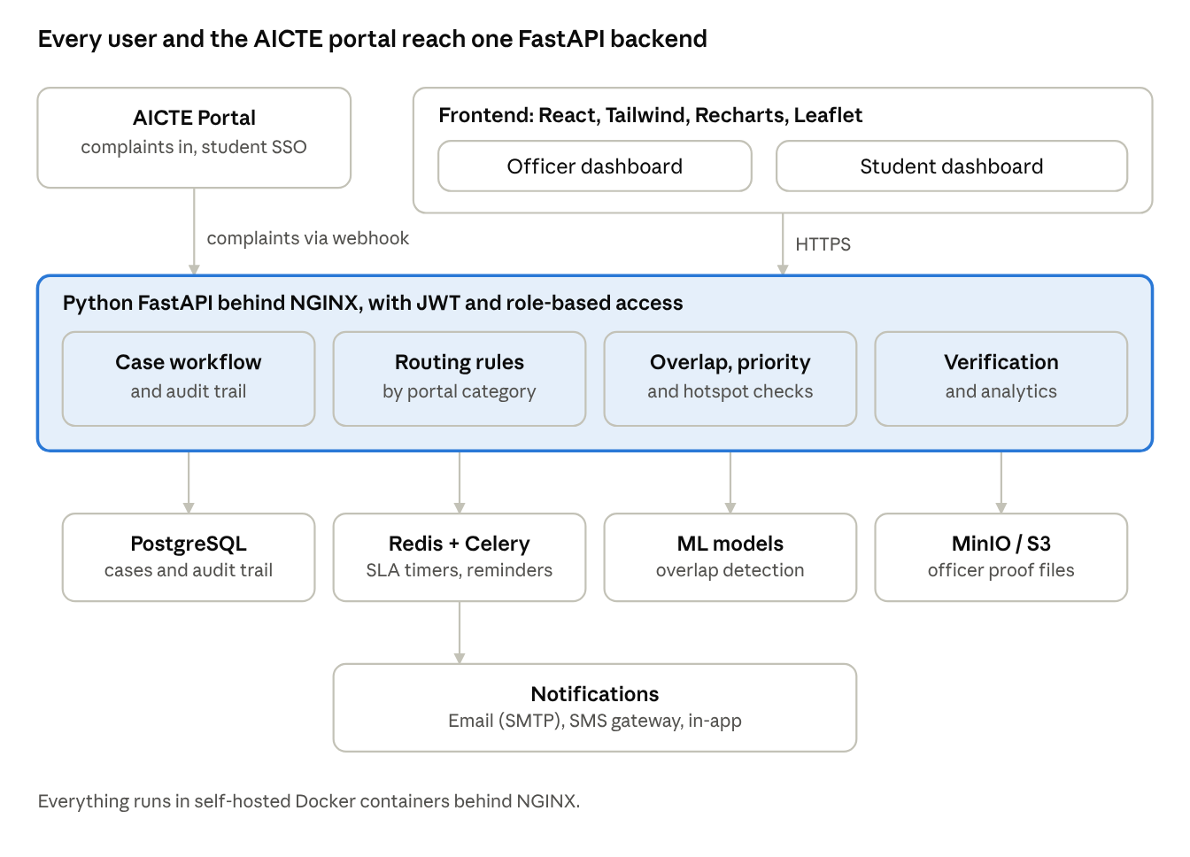
system architecture · 4 layers
Officers and students use the React front end, the AICTE portal pushes complaints in by webhook, and one FastAPI backend does the work, backed by PostgreSQL, Celery timers, an embeddings model and file storage.

7. Complaint lifecycle and flow
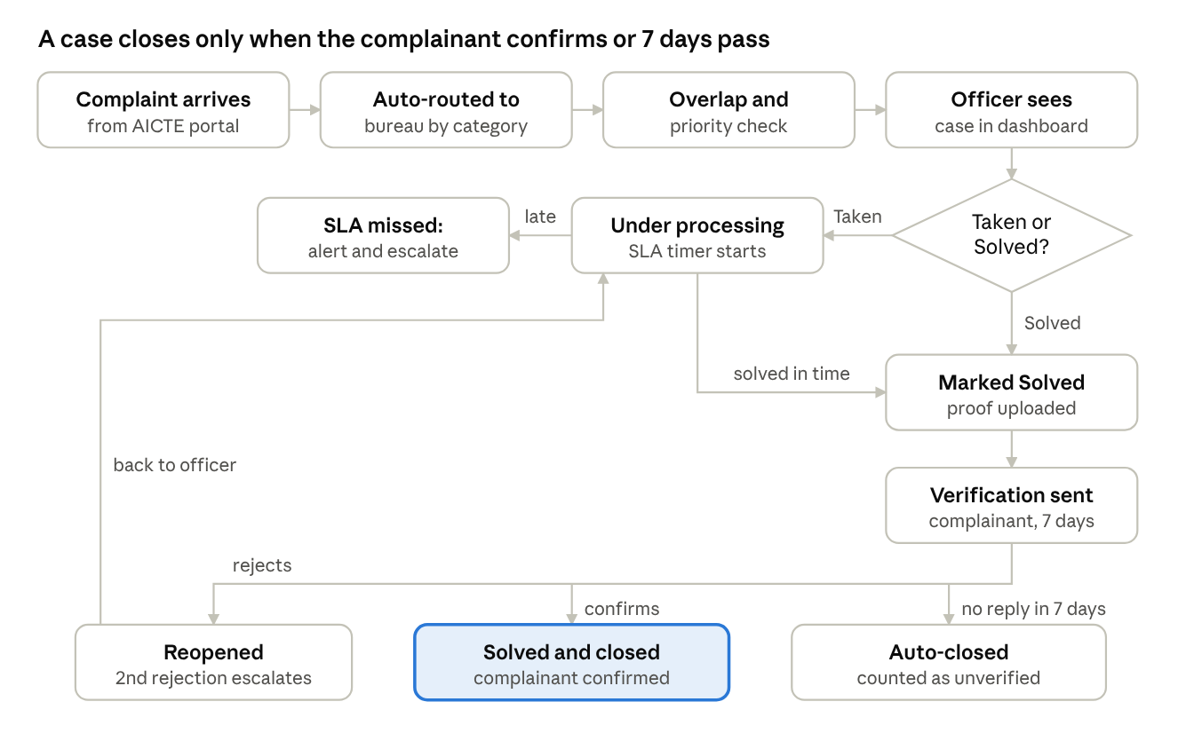
complaint lifecycle · 1 decision, 1 verification loop
Verification is the last gate: a rejection sends the case back to the officer, a second rejection escalates it, and silence for 7 days closes it as unverified.

7.1 Case statuses
Status | How a case gets there | What happens next
Pending | New case arrives and is auto-routed | Officer chooses Taken or Solved
Under processing | Officer clicks Taken; SLA timer starts | Officer solves it before the deadline, or it escalates
Pending verification | Officer clicks Solved and uploads proof | Complainant confirms or rejects within 7 days
Solved | Complainant confirms | Case closed
Reopened | Complainant rejects | Back to the officer; a second rejection escalates to a senior officer
Unverified | No reply in 7 days | Auto-closed and counted as "unverified"

8. How the intelligence layer works
- Routing: the complainant picks a category on the AICTE portal; our rules map that category to a bureau. No custom ML model is needed.
- Overlap detection: each complaint is turned into a multilingual embedding and compared with open cases of the same college. Close matches at a different bureau raise an overlap alert, and an officer can link the cases.
- Severity (Logistic Regression): reads the complaint text embedding plus its category and predicts critical, high, medium or low. Harassment, ragging and safety complaints land at critical; food or facility complaints land lower.
- Priority (LightGBM): a gradient boosting model scores each case from severity, category, repeats by the same person within 7 days, similar complaints at the same college (hotspot), SLA time left, case age, linked overlap cases and past rejections. The priority list is sorted by this score.
- Safety rule: critical categories such as harassment always stay in the top section of the list. A minor complaint that repeats can rise within the list, but never above a critical case.
- Explanations (SHAP): each row can show why it ranks high, so the ranking stays explainable and auditable.
- Training data: the prototype learns from the team's sample data. In the full application, officers' manual re-rankings become real training labels.
- Rule for all of it: the system suggests and ranks; officers and complainants make the real decisions, and every action is logged.

9. Security and audit
- JWT sessions with role-based access: each role sees only its own scope.
- Students sign in through AICTE portal SSO, with OTP fallback and expiring verification links.
- Every status change, upload, link and escalation is written to the audit trail.
- Proof files sit in self-hosted object storage; no complaint data leaves AICTE infrastructure.

10. Prototype: what we decided
Area | Decision
Scope | One full working flow: complaint in, auto-route, officer Taken or Solved with proof, student confirm or reject, analytics update. Other features are simpler
Backend | Python FastAPI
Platform | Desktop only
Look and feel | Clean white page with lots of space, one accent colour, amber and red only for warnings, rounded cards with soft shadows, one sans-serif font, line icons
Accent colour | Not final yet; shortlisted options are being compared
Dashboard style | Graph-first: donut, line and bar charts that are interactive, with exact numbers on hover or click
Not in the prototype | The map view and the Llama assistant. Both belong to the full application (section 12)
Primary button | "Open next priority case", the strongest-coloured button at the top of the sidebar
Officer screens | Overview, Complaints (pending, under processing, pending verification, solved), Priority list, Colleges, Overlaps, Officers and action history, Reports, Feedback, Settings
Officer home | Four KPI cards (pending, under processing, pending verification, SLA breached or at risk), the priority list with Taken and Solved buttons as the main card, and analytics: status donut, complaints over time, complaints by category, SLA health, top colleges by repeat complaints
Priority ranking | Logistic Regression for severity and LightGBM for the priority score, trained on the team's sample data
Scoping | The officer's login fixes state and bureau, so the dashboard opens already scoped (for example Regional Office, Bhopal, Madhya Pradesh)
Student screens | My complaints as cards with status and timeline, a previous complaints list, and a highlighted verification card with proof, Confirm and Reject buttons and a 7-day countdown
Sample data | Prepared by the team and supplied separately, so Claude Code only writes the code. Planned spread: about 50 colleges with AICTE IDs across several districts, 150 to 200 complaints in all statuses, repeat-complaint cases, overlap pairs, SLA at-risk and breached cases, and 5 to 6 officers
Build path | Run locally first without Docker, push to GitHub, then Docker for a hosted link. Code is written with Claude Code, layout first, then flow

11. Boundaries and what we need from AICTE
- Complaint filing is out of scope; complaints arrive from the AICTE portal.
- Our part is the software. AICTE decides the API or webhook access, the data fields, and the numbers that drive rules, such as SLA durations and thresholds.
- The pitch is simple: give us those inputs and we deliver a complete, auditable monitoring product.
- Portal SSO for student login still needs to be confirmed with AICTE.

12. Full application only (not in the prototype)
Feature | What it does
Map view | A "Map" option in the sidebar that shows the whole of India, or the state and district the officer is in. Each college is a dot showing how many complaints it has; clicking a district zooms in to its colleges. Built with Leaflet and India GeoJSON
Llama assistant (Stage 2) | Self-hosted Llama (Ollama or vLLM) for complaint summaries, Hindi and Hinglish understanding, and category suggestions when the classifier is unsure. It never makes the final routing, priority or verification decision. Needs GPU availability and a licence check before use
Learning from officers | Officers' manual re-rankings of the priority list become training labels that improve the priority model over time

